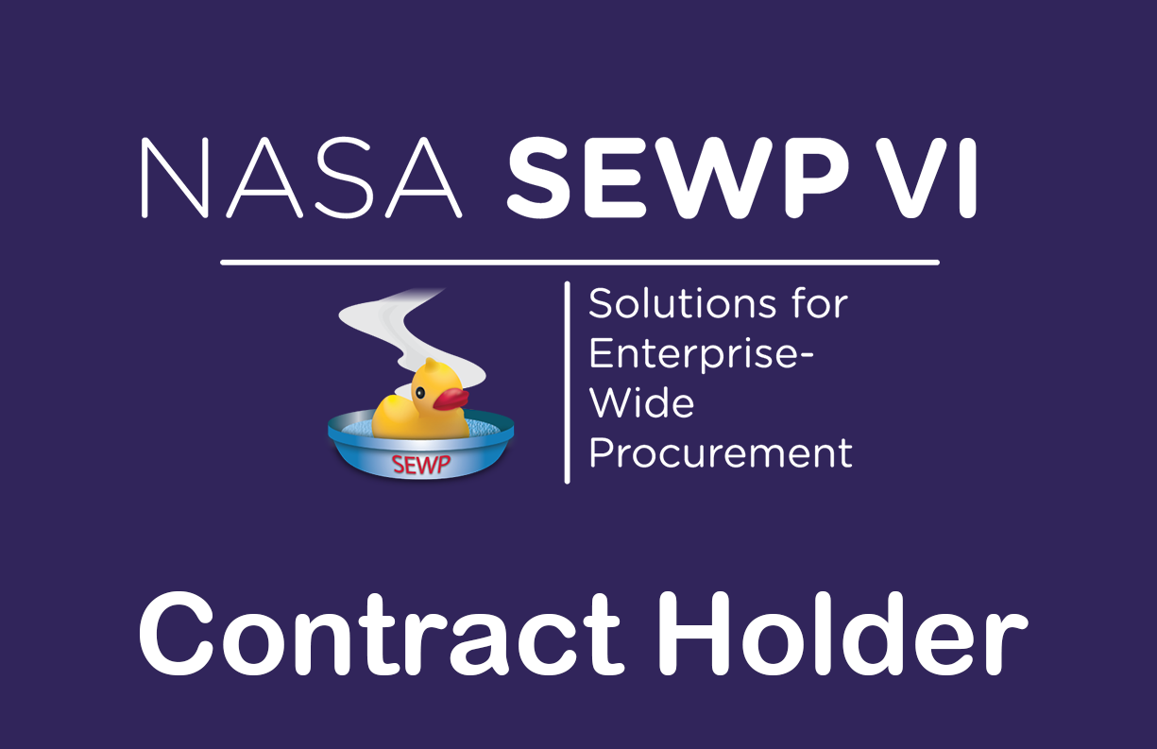

NASA SEWP VI
ORDERING GUIDE | CATEGORIES A + C
Command Control Communications Engineering & Logistics, LLC (C3EL)

About SEWP VI
NASA’s Solutions for Enterprise-Wide Procurement VI (SEWP VI), pronounced “soup,” provides Information Technology, Communications, and Audio-Visual (ITC/AV) solutions and services to federal agencies and their approved contractors. Created in 1993, SEWP I was the first Government-Wide Acquisition Contract (GWAC) in the federal acquisition space. The vehicle initially focused on technology products and has evolved over more than 30 years to support broader customer requirements. SEWP is a self-funded acquisition program supported by a usage fee of 0.34% and provides acquisition support to federal agencies.
SEWP VI includes three scope categories: Category A – ITC/AV Solutions; Category B – Enterprise-Wide ITC/AV Service Solutions; and Category C – Mission-Based ITC/AV Service Solutions. C3EL holds contracts in Categories A and C. SEWP is intended to cover the broad, evolving ITC/AV solutions-and-services landscape. For an official assessment of whether a requirement is in scope, submit a requirement overview or bill of materials (BOM) to help@sewp.nasa.gov.

About C3EL
C3EL supports federal technology requirements through IT products and mission-focused services, including computing and networking infrastructure, cybersecurity technologies, systems engineering, technology integration, and IT lifecycle support. Availability depends on the applicable contract category and approved SEWP catalog.

Fair opportunity
FAR 16.505(b)(1) provides for each contractor to be afforded a fair opportunity to be considered for applicable orders under multiple-award contracts. The ordering Contracting Officer (CO) determines the method used to provide fair opportunity and maintains the required basis for order placement and pricing decisions.
The NASA SEWP online Quote Request Tool (QRT) is a recommended means to assist the agency with fair opportunity and its acquisition documentation. The QRT can identify and include eligible Contract Holders within the selected SEWP category or based on a suggested source. Agency contracting personnel should follow the current SEWP VI contract, FAR 16.505(b), agency procedures, and applicable NASA SEWP quoting instructions.

Contract information
CATEGORY A | ITC/AV Solutions | 80TECH26D1337
CATEGORY C | Mission-Based ITC/AV Service Solutions | 80TECH26D0310
Vehicle | Multiple-award IDIQ / Government-Wide Acquisition Contract (GWAC)
Contracting agency | National Aeronautics and Space Administration (NASA)
Ordering period | November 1, 2026 – October 31, 2036
Eligible customers | Federal agencies and authorized government contractors, consistent with SEWP ordering rules
SEWP Usage Fee | 0.34% This fee is included in the price of all products and is not separately listed on quotes.

Program Contacts
SEWP VI Website | https://www.sewp.nasa.gov/sewpvi/
SEWP Helpline | help@sewp.nasa.gov  (301) 286-1478
SEWP Program Office | sewporders@sewp.nasa.gov  (301) 286-0317
C3EL Program Manager | Charles Murphy  murphyc@c3el.com  (813) 729-0374
C3EL Deputy Program Manager | Carlos Olvera  olverac@c3el.com  (813) 593-2725
C3EL Helpline | SEWPVI@c3el.com  (813) 602-5991

How to request a quote
Government customers should follow their agency procurement procedures and the NASA SEWP quote request process. To discuss a requirement, contact the C3EL SEWP VI program team. Include the applicable category, requested products or services, quantities or statement of work, delivery location, required dates, and any installation, warranty, or support needs. C3EL will confirm whether the requested offering is available under its current approved SEWP contract before providing a quote.
Program Manager / Sales: Charles Murphy | murphyc@c3el.com
Deputy Program Manager / Sales: Carlos Olvera | olverac@c3el.com
General office phone: 813-620-0051

Ordering process
The internal ordering process of each Agency varies. The process and accompanying forms for Purchase Requests (PR) and Delivery Orders (DO) that are issued against a SEWP contract is defined by the issuing Agency, not the NASA SEWP Program Management Office (PMO). The typical process is for an end-user to determine a requirement and generate a Purchase Request (PR).
The PR along with any necessary funding information is sent to that Agency's procurement office which results in the issuance of a DO. Any valid Federal Agency DO form, and the associated Delivery Order number may be used. The NASA SEWP Program Management Office (PMO) does not issue DOs - these must be issued through the issuing Agency's procurement office. The SEWP Program Management Office (PMO) reviews, processes and tracks issued DOs and forwards them to the Contract Holder(s).
Some Agencies have special requirements for issuing IT Delivery Orders. It is the Issuing Agency's Contracting Officers' (COs/KOs) responsibility to be aware of any Agency-specific policies regarding issuing orders via an existing contract vehicle and Government-Wide Acquisition Contracts. There are no requirements under the SEWP Contracts for issuing Agencies to use other intermediary procurement offices, except as directed through their own internal policies.
If modifications are made to any order, these modifications must also route through the SEWP Program Management Office (PMO).

Installation, warranty & post-delivery support
Installation, basic or extended warranty, maintenance, technical support, and software support depend on the applicable purchase, manufacturer or publisher terms, and the issued order. Customers may request coverage and support details during quotation. For assistance after delivery, contact the C3EL program team above and provide the delivery order number, item or service description, serial number (if applicable), and issue details. C3EL will coordinate the response with the responsible manufacturer, distributor, or service provider as appropriate.

Troubleshooting an order
For delayed shipments, shortages, incorrect or damaged deliveries, warranty claims, technical or software issues, or discrepancies in an order, contact the C3EL SEWP VI program team at the email addresses above or through the general office number. Include the order number, affected items and a description of the problem. Unresolved issues may be escalated to the Program Manager, Charles Murphy. Government-directed order changes must be handled through the authorized ordering office and required SEWP channels.

C3EL office
5670 West Cypress Street, Suite C | Tampa, Florida 33607
Main office: 813-620-0051
Corporate website: https://c3el.com/

NASA SEWP resources
NASA SEWP website: https://www.sewp.nasa.gov
NASA SEWP help desk: help@sewp.nasa.gov | 301-286-1478
SEWP usage fee: 0.34%

